IoT PLC — Embedded Linux SoC Selection
Oct 3, 2026 · @MohammadJavad

Why embedded Linux
A Linux processor should replace the ESP32-S3 as the communication and application brain, while the STM32H750 stays as the real-time I/O processor. This split keeps the deterministic PLC scan (DI/DO/AI/AO, watchdog, power-fail latch) on bare metal and moves everything that changes often to Linux.
What Linux adds that the ESP32 cannot:
- Native Ethernet (one or two ports), Modbus TCP server, OPC UA, MQTT/Sparkplug B and a web HMI at the same time
- Secure boot, encrypted storage, A/B firmware updates and signed packages (needed for IEC 62443 / EU Cyber Resilience Act)
- Containers or Python/Node-RED on the device for customer logic and protocol converters
- Larger storage for data logging (eMMC) and a USB host for sticks and LTE modems
- An IEC 61131-3 runtime (CODESYS Control for Linux, or the open-source OpenPLC/Beremiz) next to the I/O firmware
What stays on the current board: the I/O pages, power supply, RS-485/RS-232, RTC, FRAM latch memory and the expansion bus. Only the Connection page (ESP32) changes.

Requirements for the processor
Requirement | Target | Why it matters for this PLC
Ethernet | 2 × 10/100/1000 MAC, ideally with a switch or TSN | Daisy-chain line topology, Modbus TCP, OPC UA
Temperature | −40 to +85 °C ambient (industrial grade) | Control cabinets
Longevity | 10+ years in the vendor's longevity programme | Industrial customers re-order for a decade
Security | Secure boot, crypto engine, TrustZone/OP-TEE, OTP keys | CRA and IEC 62443-4-2
Memory | 256–512 MB DDR3L/DDR4/LPDDR4, 4–8 GB eMMC | Linux + logging + web HMI
PCB difficulty | Package with 0.8 mm ball pitch, single 16-bit DDR, 4–6 layers | Your team designs and builds it in-house
Power | 1–2 W typical, discrete regulators or one PMIC | Runs from the existing 24 V → 5 V → 3.3 V chain
Real-time link | SPI or UART to the STM32H750 (or an on-chip MCU core) | Keeps the I/O scan deterministic
Software | Mainline Linux + Yocto/Buildroot BSP, long-term support | Low maintenance cost
Cost | Under about US$15 for the SoC | Keeps the head-unit BOM competitive

Candidate processors
Three families fit an industrial PLC well: ST STM32MP1/MP2, NXP i.MX 93 and TI AM62x. Allwinner and Rockchip parts are cheaper, but their documentation, longevity and security are weak for an industrial product.
SoC | CPU / real-time core | Ethernet | DRAM | Package (pitch) | Temp. / longevity | Integration effort
STM32MP135F | 1 × Cortex-A7 1 GHz / none | 2 × GbE, IEEE 1588 | 16-bit DDR3L or LPDDR2/3, up to 1 GB | LFBGA289 14×14 mm (0.8 mm) | Industrial, 10-year ST longevity | Lowest: 4-layer board possible, discrete power
STM32MP235 / MP23x | 1–2 × Cortex-A35 1.5 GHz / Cortex-M33 400 MHz, NPU 0.6 TOPS | 2 × GbE with TSN | 16-bit DDR3L/DDR4/LPDDR4, up to 4 GB | TFBGA361 16×16 / TFBGA436 18×18 (0.8 mm) | −40…+125 °C Tj, 10 years; from US$8.46 @1k | Medium: 6 layers, PMIC
STM32MP257 | 2 × A35 + M33, NPU 1.35 TOPS | 3 × GbE incl. TSN switch | 32-bit DDR4/LPDDR4 | 0.8 mm and 0.5 mm options | Industrial, 10 years | Medium–high
NXP i.MX 93 | 2 × Cortex-A55 / Cortex-M33 250 MHz, Ethos-U65 NPU | 2 × GbE, one with TSN | 16-bit LPDDR4/4X with inline ECC | 14×14 (0.65 mm), 11×11 and 9×9 (0.5 mm) | −40…+125 °C, 15 years | Medium–high: 0.5/0.65 mm pitch, LPDDR4
TI AM62x (approximate, from memory) | 1–4 × Cortex-A53 1.4 GHz / Cortex-M4F | 2-port GbE switch with TSN | DDR4/LPDDR4 | 17×17 mm (0.8 mm) | Industrial, long TI support | Medium: 6+ layers
For this PLC the decision is between the STM32MP135 (simplest, cheapest to integrate) and the STM32MP23x (more performance, on-chip M33, TSN). Both stay in the STM32 tool chain your team already uses for the H750.

Recommendation
Use the STM32MP135F in the LFBGA289 (14×14 mm, 0.8 mm pitch) package, with the STM32H750 kept as the I/O co-processor. It is the most integration-friendly Linux processor that still meets every industrial requirement.
Why it is the optimal choice for this product:
- Two Gigabit Ethernet MACs on chip, so a dual-port head unit needs only two RGMII PHYs (or one PHY plus a 3-port switch for line topology).
- Easiest board design in the class: 0.8 mm ball pitch, a single 16-bit DDR3L chip and ST reference designs that fit on 4 layers. You can keep building in-house.
- Same ecosystem as the H750: STM32CubeIDE/CubeMX, OpenSTLinux (Yocto), ST forums and FAEs. No new vendor to learn.
- Security that matches the CRA: secure boot, TrustZone with OP-TEE, crypto engine and on-the-fly DDR encryption.
- Low power (well under 1 W typical), so the existing 24 V → 5 V → 3.3 V supply only needs a DDR rail and a core rail added.
- Two CAN FD and ADCs on chip if you later want CANopen or extra analog monitoring.
When to choose the STM32MP23x instead: when you need TSN, a vision/AI model on the device, or want to drop the H750 and run the real-time I/O scan on the on-chip Cortex-M33. Expect a 6-layer board and a PMIC.
What the MP135 does not have: no on-chip MCU core (hence keeping the H750) and no NPU. Neither is needed for a PLC head unit.

Reference architecture
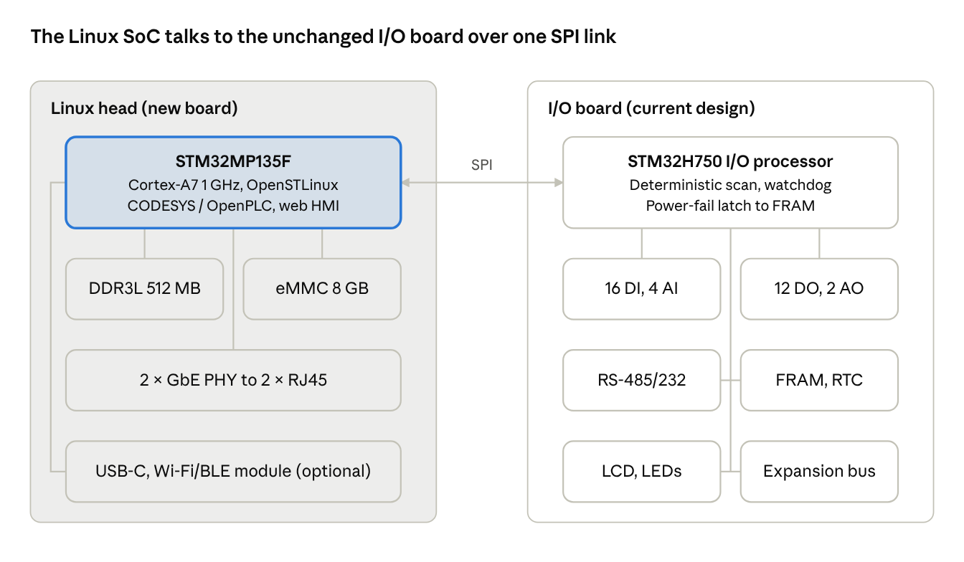
v2 architecture · Linux head + existing I/O board
Only the ESP32 Connection page is replaced. The H750 keeps USART3 free for an optional Wi-Fi module and exchanges a CRC-protected process image with the MP135 over SPI every scan.

Integration path
Start with a system-on-module, then move the same SoC chip-down once volume justifies it. The SoM removes the DDR and power-sequencing risk from the first release.
Path | When | Board work | Risk
SoM (STM32MP13 module from an ST partner) on the head board | First 100–1000 units | Carrier board only, 4 layers | Low; module costs more
Chip-down STM32MP135F + DDR3L + eMMC | Volume above about 1000/year | Copy ST reference layout, DDR length matching | Medium; needs SI review
Software stack:
- OS: OpenSTLinux (Yocto) with an A/B rootfs and RAUC or SWUpdate for signed updates
- Runtime: CODESYS Control for Linux (commercial) or OpenPLC/Beremiz for IEC 61131-3; Node-RED optional
- Protocols: Modbus TCP/RTU, OPC UA (open62541), MQTT/Sparkplug B to AWS IoT, web HMI over HTTPS
- I/O link: SPI at 10–20 MHz to the H750 with a framed process image (inputs, outputs, diagnostics, CRC), refreshed every scan
Roadmap:
- Now: finish v1 (H750 + ESP32-S3), keep Ethernet out of v1 or add a W5500 on the ESP32 SPI bus
- v2 prototype: STM32MP135 SoM on a new Connection board, ESP32 kept only as Wi-Fi/BLE co-processor (or dropped)
- v2 production: chip-down MP135, dual Ethernet, secure boot provisioned at end-of-line test
- v3 option: STM32MP23x with TSN and on-chip M33 when customers ask for TSN or edge AI

Sources
- STM32MP135F datasheet (ST)
- STM32MP23 launch details (CNX Software)
- STM32MP25 overview (ST blog)
- i.MX 93 family fact sheet (NXP)

